DSA06 - Data Handling and Visualization
Activity: Identify Skewness using Violin Plots
- No: 8 Reg. No: 192325043 Name: Bandaru Jahnavi

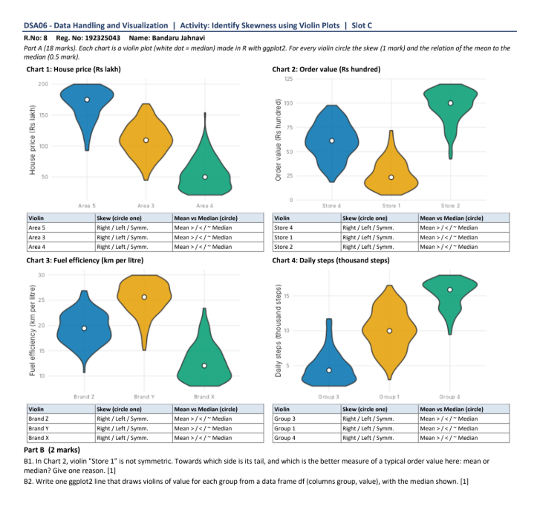

Part A
A violin with a long tail pointing up (right) is right-skewed, so the mean is above the median. A long tail pointing down (left) is left-skewed, so the mean is below the median. A balanced violin is symmetric, so the mean is about equal to the median.
Chart | Violin | Skew | Mean vs median
1: House price | Area 5 | Left | Mean < Median
 | Area 3 | Symmetric | Mean ≈ Median
 | Area 4 | Right | Mean > Median
2: Order value | Store 4 | Symmetric | Mean ≈ Median
 | Store 1 | Right | Mean > Median
 | Store 2 | Left | Mean < Median
3: Fuel efficiency | Brand Z | Symmetric | Mean ≈ Median
 | Brand Y | Left | Mean < Median
 | Brand X | Right | Mean > Median
4: Daily steps | Group 3 | Right | Mean > Median
 | Group 1 | Symmetric | Mean ≈ Median
 | Group 4 | Left | Mean < Median

Part B
B1. In Chart 2, Store 1's tail points towards the higher order values (the right). The median is the better measure of a typical order value. The few large orders in the tail pull the mean upwards, while the median stays near where most orders are (about Rs 23 hundred).
B2.
ggplot(df, aes(x = group, y = value)) + geom_violin() +
stat_summary(fun = median, geom = "point", colour = "white", size = 3)

